1. SQL Exercise - Advanced concepts

Exercise 1: Ranking and Window Functions

CREATE TABLE Products (
ProductID INT,
ProductName VARCHAR(100),
Category VARCHAR(50),
Price DECIMAL(10, 2)
);

INSERT INTO Products (ProductID, ProductName, Category, Price) VALUES
(1, 'Apple iPhone 14', 'Mobiles', 900),
(2, 'Samsung S21', 'Mobiles', 800),
(3, 'OnePlus 10', 'Mobiles', 850),
(4, 'Redmi Note 10', 'Mobiles', 300),
(5, 'LG OLED', 'TV', 1500),
(6, 'Samsung QLED', 'TV', 1400),
(7, 'Sony Bravia', 'TV', 1450),
(8, 'MI TV', 'TV', 700),
(9, 'HP Laptop', 'Laptops', 1200),
(10, 'Dell XPS', 'Laptops', 1250),
(11, 'Asus ROG', 'Laptops', 1300),
(12, 'Lenovo ThinkPad', 'Laptops', 1150);

SELECT *
FROM (
SELECT *,
ROW_NUMBER() OVER (PARTITION BY Category ORDER BY Price DESC) AS RowNum
FROM Products
) AS Ranked
WHERE RowNum <= 3;

SELECT *
FROM (
SELECT *,
RANK() OVER (PARTITION BY Category ORDER BY Price DESC) AS RankNum
FROM Products
) AS Ranked
WHERE RankNum <= 3;

SELECT *
FROM (
SELECT *,
DENSE_RANK() OVER (PARTITION BY Category ORDER BY Price DESC) AS DenseRankNum
FROM Products
) AS Ranked
WHERE DenseRankNum <= 3;

OUTPUT: 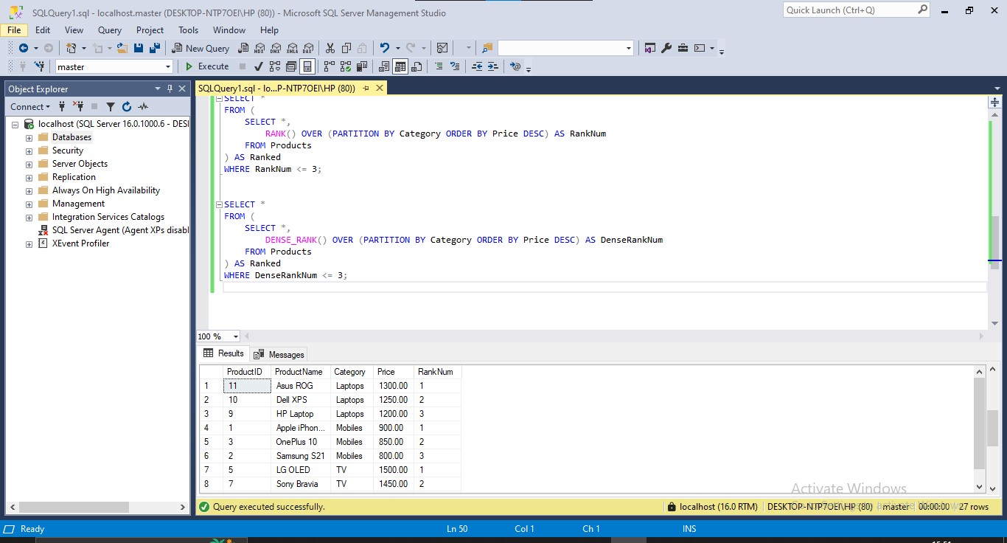
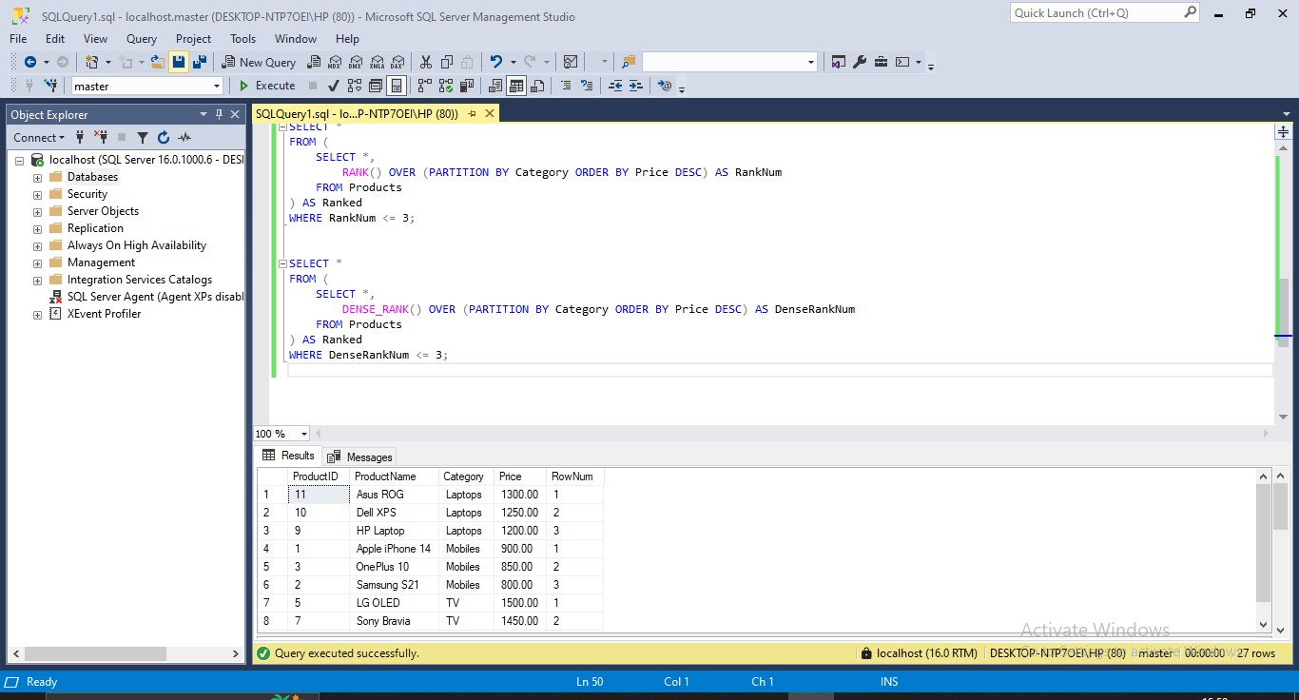

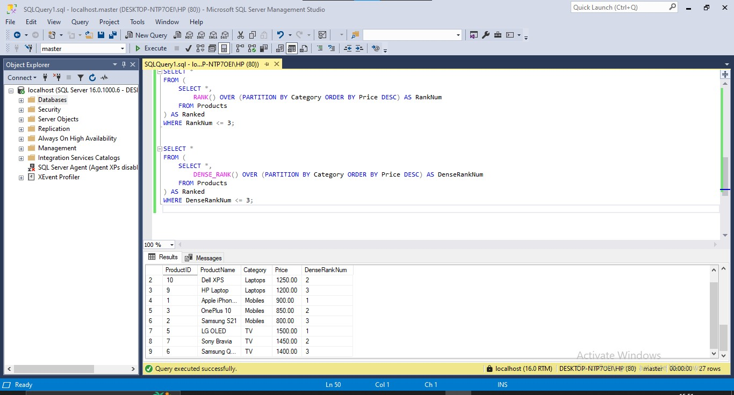

4. SQL Exercise - Stored procedure

Exercise 1: Create a Stored Procedure

EXEC sp_InsertEmployee
@FirstName = 'Rithi',
@LastName = 'Krithi',
@DepartmentID = 3,
@Salary = 7500.00,
@JoinDate = '2023-06-29';
EXEC sp_InsertEmployee 'Arjun', 'Mehta', 1, 5200.00, '2020-02-10';
EXEC sp_InsertEmployee 'Priya', 'Verma', 2, 6300.00, '2019-06-18';
EXEC sp_InsertEmployee 'Rajesh', 'Iyer', 3, 7200.00, '2021-03-25';
EXEC sp_InsertEmployee 'Anjali', 'Nair', 4, 5800.00, '2022-01-12';
EXEC sp_InsertEmployee 'Deepak', 'Reddy', 3, 7100.00, '2023-05-03';
EXEC sp_InsertEmployee 'Kavya', 'Sharma', 2, 6450.00, '2020-11-09';
EXEC sp_InsertEmployee 'Naveen', 'Das', 1, 4950.00, '2021-09-15';

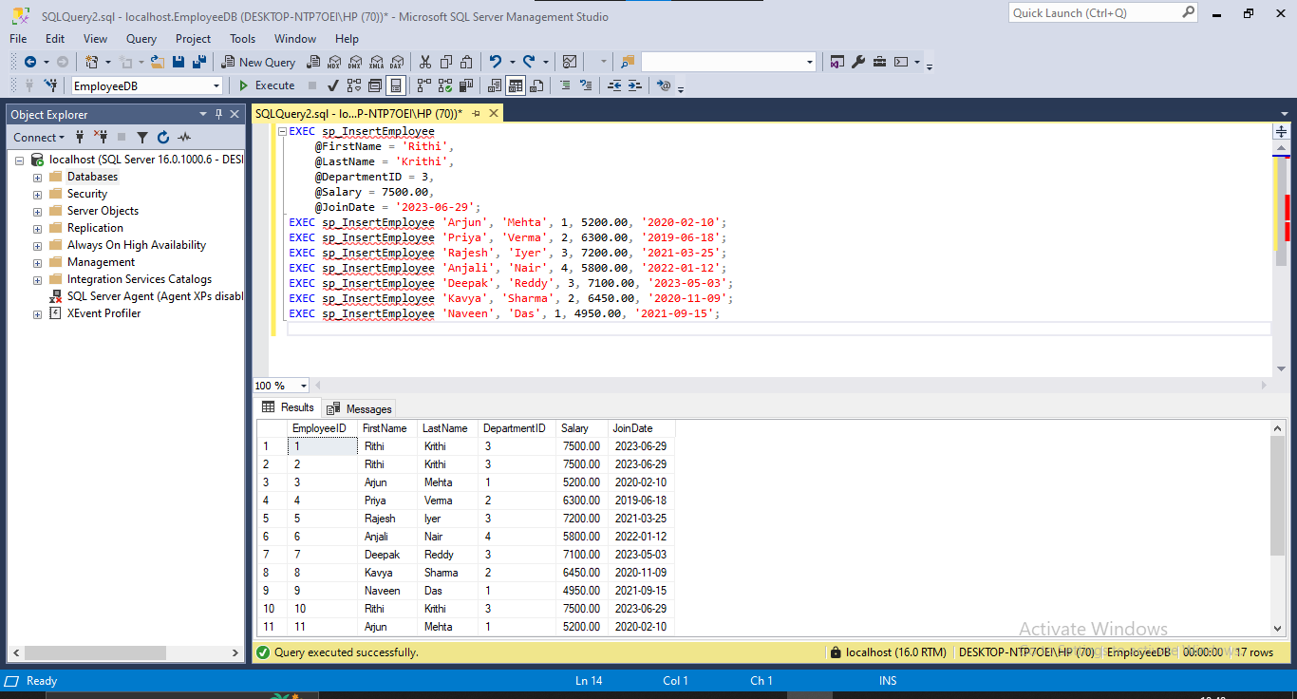

Exercise 5: Return Data from a Stored Procedure

CREATE PROCEDURE sp_CountEmployeesByDepartment
@DepartmentID INT
AS
BEGIN
SELECT COUNT(*) AS TotalEmployees
FROM Employees
WHERE DepartmentID = @DepartmentID;
END;
GO

EXEC sp_CountEmployeesByDepartment @DepartmentID = 3;

